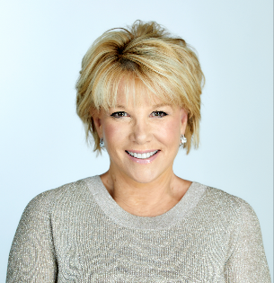
An award-winning journalist, bestselling author, television host, and motivational speaker, Joan Lunden has been a trusted voice in American homes for more than 40 years. For nearly two decades, Lunden greeted viewers each morning on Good Morning America making her the longest running female host ever on early morning television.

Lunden continues to be one of America’s most recognized and trusted personalities which has made her a sought-after speaker for events across the country. As an ardent health & senior advocate, Lunden has testified before the Food and Drug Administration advocating mandatory mammogram reporting and the Congressional House Ways and Means Committee advocating for the Family and Medical Leave Act.

Lunden is the host of the host the PBS television series, Second Opinion with Joan Lunden and the Washington Post Podcast series, Caring for Tomorrow on the future of healthcare. Lunden is also the ambassador to the Poynter Institute’s MediaWise for Seniors program which educates individuals over 50 on media literacy - separating fact from fiction online. Recently, Lunden joined the faculty of Lehigh University as a visiting professor in their College of Health teaching Population Health and the Media.

As a part of the sandwich generation, Lunden’s demographic is far-reaching. She is a mother of 7 including two sets of teenage twins. Like many Boomers in America, she has juggled being a working mom while caring for an aging parent and brings this experience to her role as an active advocate for seniors. One of the most visible women in America, Lunden has graced the covers of more than 60 magazines and book covers. Lunden’s newest book, Why Did I Come into This Room: A Candid Conversation About Aging quickly became a New York Times Best Seller.

In June of 2014, Lunden was diagnosed with triple negative breast cancer. An eternal optimist, she turned her diagnosis into an opportunity to become an advocate and help others. She chronicled her experience in her memoir Had I Known. Lunden continues to interact with American’s daily on her website, Joanlunden.com as well as her social media platforms. Lunden has served as national spokesperson for various organizations such as the American Heart Association, Mothers Against Drunk Driving, American Lung Association, American Red Cross, American Academy of Pediatrics, and the Colon Cancer Alliance.

Joan Lunden’s books include Why Did I Come into This Room: A Candid Conversation About Aging; Had I Known; Chicken Soup for the Soul: Family Caregiving; Growing Up Healthy: Protecting Your Child from Diseases Now Through Adulthood; Wake-Up Calls; A Bend in the Road is Not the End of the Road; Joan Lunden’s Healthy Living;
Joan Lunden’s Healthy Cooking; Mother’s Minutes; Your Newborn Baby; and Good Morning, I’m Joan Lunden.
Joan Lunden truly exemplifies today’s modern working woman

