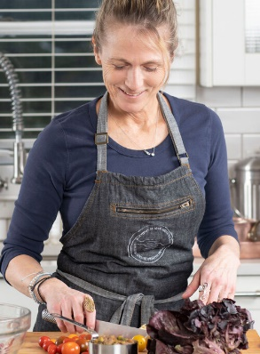

Stefanie is a self-proclaimed nourishment warrior and nationally recognized Culinary Nutritionist, educator, speaker, consultant and leading authority on eating to prevent and manage illness. For over two decades, she has helped transform the way people eat using hands on experiences to inspire, educate and offer practical tools for food lifestyle change. She has her Master of Science in Nutrition from Teachers College, Columbia University, is a Certified Nutrition Specialist®, Certified Dietitian Nutritionist and is a graduate of the Natural Gourmet Institute for Health and Culinary Arts.
As a chef, nutritionist and innate healer she uses food as a conduit to deep transformation. She empowers people to eat and live to their full potential. Her book What The Fork Are You Eating (now available in audio) is a must-read guide for anyone looking to make small changes in food choice for optimal health.
She is a media guest expert on the topic of healthy choices with frequent appearances on the Dr. Oz Show, PBS, Fox Media, and multiple radio programs. Her extensive online and print contributions include Oprah.com, Bloomberg, The Huffington Post, Alternet, fortune.com, foxnews.com and foxbusiness.com, Family Circle, Prevention, Harper’s Bazaar, Parents, Town & Country and Allure.
In 2017 Stefanie was inducted into Les Dames D'Escoffier, an international philanthropic organization of women leaders in the field of food, fine beverage and hospitality. She is a member of the Academy of Nutrition and Dietetics, International Association for Culinary Professionals and sits on the advisory board of A Greener World and East End Food Institute.
A native New Yorker, Stefanie lives on the East End of Long Island with her husband, two very active boys and Faith, her beloved lab rescue. When she is not in her kitchen creating new recipes or feeding her family, she is either swimming in the bay or hiking with her pup.

